The inaugural Black Women in Data Summit is on October 1st and 2nd 2022. This 2- day forum for mid-career Black women leaders to plan their next career move in the data industry by hearing from data expert speakers, expanding their data skills, learning current equitable data practices and more.

This is a can’t miss event for me. It is an amazing opportunity to help advance my learning and development goals by participating in:
- Carefully selected data skills workshops to sharpen my toolkit for my role
- Keynote presentation featuring the latest trends and thought leadership in data industry
- Network with peers across industries to exchange ideas with people who have the same role or interests.
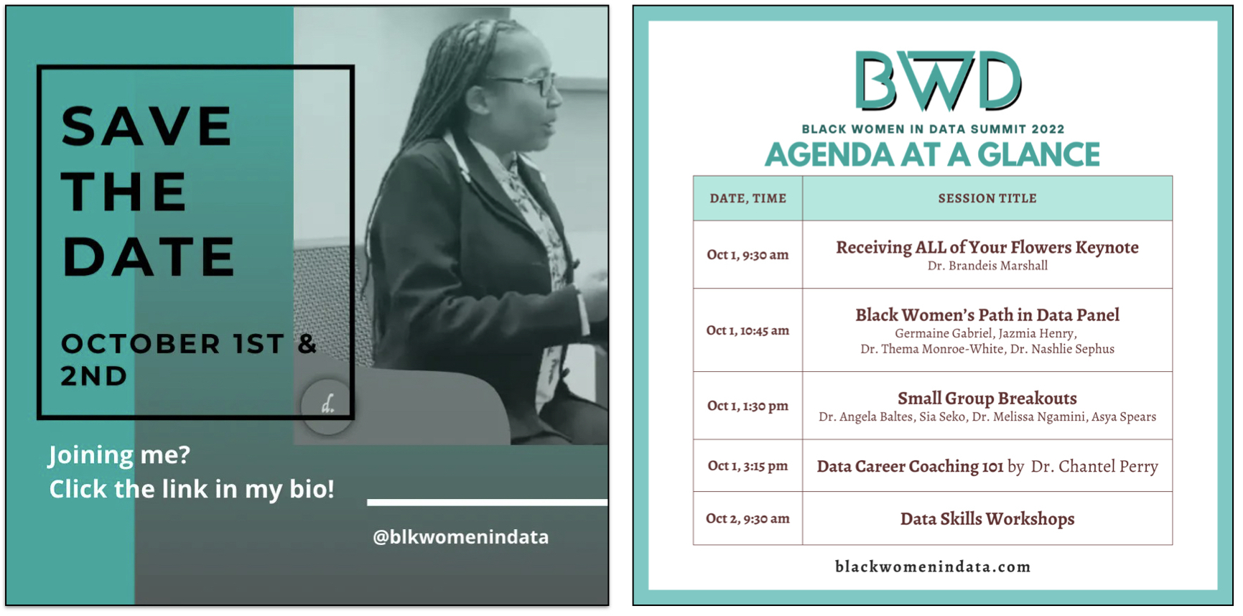
With immense learnings and experiences offered, this summit is not one to miss. Dr. Brandeis Marshall is a thought leader, scholar and educator in this space. She has been leading a private community of mid-career data-centric Black women for over 2 years. You can check out more summit site here. Summit highlights include:
Breakdown of potential costs:
Airfare/Train/Mileage: $ Adjust depending on your city of departure.
Transportation: $ Taxis/ubers if applicable
Hotel: $ Adjust depending on your hotel of choice
Meals: $ 2 Breakfast and 1 Lunch meals are included
Conference Fee: $595 - this Advance Pass price expires August 15, 2022
$750 - Regular Pass price begins August 16, 2022

TOTAL: $

Thank you for your consideration!

